|  |  |  |  |
| --- | --- | --- | --- |
| |  |  |  | | --- | --- | --- | | Seal | Biography | Flag | |
| ***U N I T E D   S T A T E S   A I R   F O R C E*** |

**CHIEF MASTER SERGEANT WILLIAM J. KEITER**

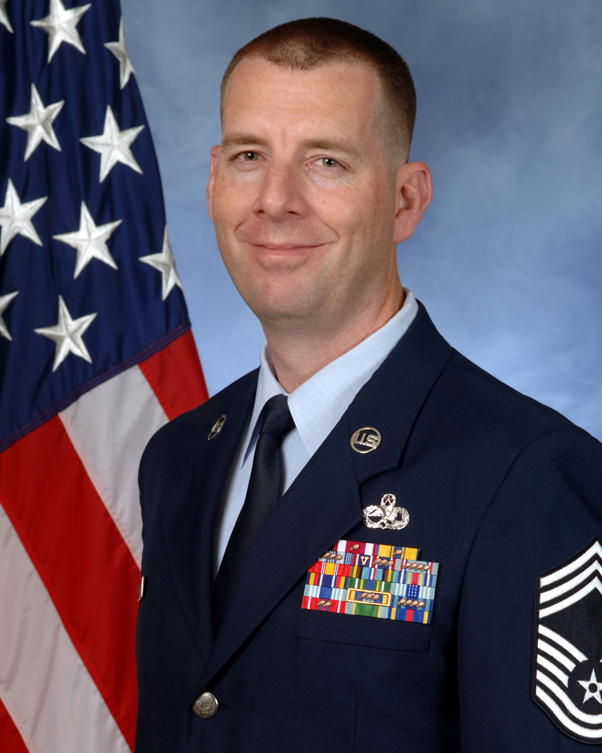

Chief Master Sergeant William J. Keiter is the Superintendent of the F-22 Aircraft Maintenance Unit, 15 Aircraft Maintenance Squadron, Joint Base Pearl Harbor Hickam, Hawaii. In this position, he leads a diverse team of 217 Total Force Airmen in partnership with the Hawaii Air National Guard to provide on-equipment maintenance for 20 of the world’s premiere F-22A fighter aircraft valued at $2.6B. He ensures safe and timely execution of an annual flying hour program consisting of 2,300 sorties and 3,100 flying hours while maintaining a Pacific Air Force Alert mission supporting operations across Hawaii and throughout the Pacific Theater.

Chief Master Sergeant Keiter was born in Dayton, Ohio and graduated from Xenia High School in 1997 and entered the Air Force in June of the same year. He attended technical training at Sheppard Air Force Base, Texas and subsequently reported to Cannon Air Force Base, New Mexico as an F-16C Communications, Navigation, and Penetration Aids Avionics Systems Specialist. His maintenance background encompasses F-16C/D, MQ-1, A-10, and F-22A airframes. His assignments include bases in New Mexico, Republic of South Korea, Nevada, Texas, Alaska, and Hawaii. Additionally, Sergeant Keiter has deployed four times in support of diverse operations throughout Southwest Asia.

**EDUCATION**

1998 F-16 Communication, Navigation, and Penetration Aids Apprentice course, Sheppard AFB, Texas

2002 Graduate, Airman Leadership School, Nellis AFB, NV

2004 Graduate, Air Force Basic Instructor course

2005 Associate in Applied Science Degree, Avionics System Technology, CCAF

2005 Associates in Instructor of Technology and Military Science, CCAF

2007 Graduate, Gaylor Noncommissioned Officer Academy, Lackland AFB, TX,

2010 Bachelor of Science in Professional Aeronautics, Embry Riddle Aeronautical University

2010 Pacific Air Force Inspector General Basic Inspectors course

2012 Professional Manager Certification, CCAF

2013 Graduate, Air Force Senior Noncommissioned Officer Academy, Maxwell-Gunter AFB, Alabama

2014 Instructional Systems Design (ISD) Certification, CCAF

2015 Senior Enlisted Joint Professional Military Education (SEJPME I)

2017 Chief’s Orientation Course, Hickam AB, Hawaii

**ASSIGNMENTS**

1. Jun 97 – Aug 97, Trainee, Basic Military Training, Lackland AFB, TX

2. Aug 97 – Oct 97, Student, Electronic Principles course, Lackland AFB, TX

3. Oct 97 – Mar 98, Student, F-16C/D Avionics Systems Apprentice course, Sheppard AFB, TX

4. Mar 98 – Dec 99, F-16 Avionics Apprentice, 522th Fighter Squadron, Cannon AFB, NM

5. Dec 99 – Jan 01, F-16 Avionics Journeyman, 36th Fighter Squadron, Osan AB, Korea

6. Jan 01 – Feb 04, MQ-1 Avionic Journeyman, 15th Reconnaissance Squadron, Indian Springs AFB, NV

7. February 04 – May 09, F-16 Fighter Avionics Instructor, 365th Training Squadron, Sheppard AFB, TX

8. May 09 – Oct 11, Specialist Section Chief, 354th Aircraft Maintenance Unit, Eielson AFB, AK

9. Oct 11 – May 12, Production Superintendent, 354th Aircraft Maintenance Unit, Eielson AFB, AK

10. May 12 – Oct 12, 2A3X5 CDC Writer, 365th Training Squadron, Sheppard AFB, TX

11. Nov 12 – May 13, Fighter Avionics Flight Chief, 365th Training Squadron, Sheppard AFB, TX

12. May 13 – Jul 15, Squadron Superintendent, 365th Training Squadron, Sheppard AFB, TX

13. July 2015 – Mar 16, Assistant Superintendent, 36th Aircraft Maintenance Unit, Osan AB, Korea

14. Apr 16 – Jul 16, Superintendent, 25th Aircraft Maintenance Unit, Osan Ab, Korea

15. Jul 16 – Present, Superintendent, 19th Aircraft Maintenance Unit, Joint Base Pearl Harbor Hickam, Hawaii

**MAJOR AWARDS AND DECORATIONS**

Air Force Meritorious Service Medal with two oak leaf clusters

Air Force Commendation Medal with one oak leaf cluster

Air Force Achievement Medal with three oak leaf clusters

AF Outstanding Unit Award with Valor Device

Armed Forces Expeditionary Medal

Global War on Terrorism Expeditionary Medal

Global War on Terrorism Service Medal

Korean Defense Service Medal

Air Force Expeditionary Service Ribbon with Gold Border

Small Arms Expert Marksmanship Ribbon

#### OTHER ACHIEVEMENTS

1998 Top Graduate, F-16 Avionics Technical Training course, Sheppard AFB, TX

2007 Distinguished Graduate, Noncommissioned Officer Academy, Lackland AFB, TX

2008 Master Instructor Certification, Sheppard AFB, TX

2010 Lance P. Sijan Award-SNCO, 354th Maintenance Group, Eielson AFB, AK

2010 Summa Cum Laude, Embry Riddle Aeronautical University

2010 SNCO of the Year, 354th Maintenance Group, Eielson AFB, AK

2011 PACAF Outstanding EW SNCO of the Year

2013 SNCO of the Year, 365th Training Squadron, Sheppard AFB, TX

2014 Support SNCO of the Year, 365th Training Squadron, Sheppard AFB, TX

2015 SNCO of the Year, 51st Aircraft Maintenance Squadron, Osan AB, Korea

2016 Lance P. Sijan Award-SNCO, 51st Maintenance Group, Osan AB, Korea

**EFFECTIVE DATE OF PROMOTION**

Chief Master Sergeant August 2017

*(Current as of Jan 2018)*